- IMPROVING CONTROL OF THERMAL ENERGY STORAGE BY MODELLING OF ENERGY DEMAND using Machine learning Methods
A thermal energy storage (TES) stores thermal energy intermittently for later use. It is applied when there is thermal supply-demand mismatch. The operation policy is that the storage stores thermal energy when there is surplus supply and releases it at periods of peak heat demand. If the stored energy is not enough to satisfy thermal demand at that time, an emergency, expensive heating source is used to fill the gap. An MPC formulated with an economic cost objective can be used to optimally control the system while ensuring demand satisfaction.
The issue is that MPC requires prediction of the supply and demand profile in throughout the optimization horizon. If the demand predictions are not close to reality, the controller will make non-optimal decisions hence poor performance. The supply profiles of the heat sources are often known and less variable, but this is not the case with thermal demand. However, there is daily periodicity in heating demand profile which is usually affected with the sink behavior and other factors such as weather. It is possible to apply statistical learning methods to develop a specific model based on historical data that is continuously updated with incoming new information. This idea is illustrated by Figure 2 below.
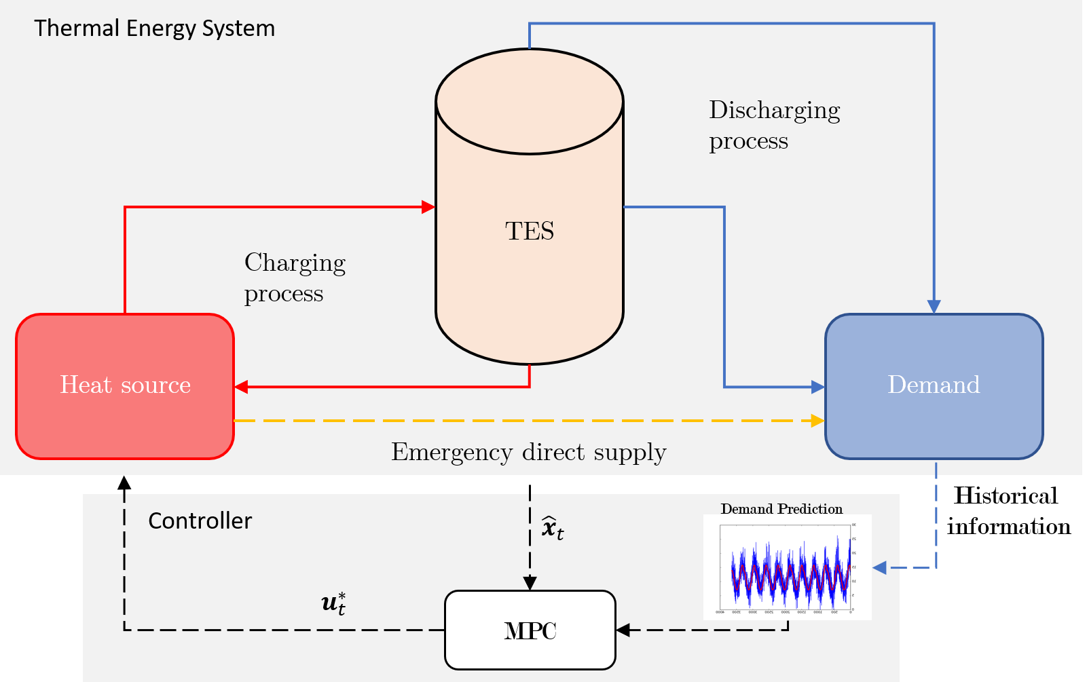
Figure 2. Schematic of Improved TES control with Data-driven MPC predicting thermal demand.
We aim at developing a thermal demand predictive model for the purpose of improving model predictive control of the thermal energy storage. The tasks for this project are but no limited to:
- Modeling demand profile for prediction and control
- Use of historical data to learn heating demand patterns
- Combining heat demand learning module with a standard MPC controller.
- Demonstrate use of new available information in operation to improve the prior model.

