**Implementing a health-aware controller in an experimental lab rig**

Supervisor: Johannes Jäschke Cosupervisor: Jose Otavio Matias

**Project goals:**

Develop a model predictive control approach that incorporates equipment degradation models and implement it in an experimental lab rig.

***Why this project?***

There is an intuitive trade-off between optimizing production and minimizing equipment degradation. In oil wells, for example, we would like to extract as much oil as possible. However, such strategy has a negative effect on the remaining useful life of the equipment. Choke valves tend to degrade faster if we increase the throughput, for instance. In order to avoid equipment wear, process engineers and operators often adopt conservative production strategies, leading to sub-optimal operation and potential profit loss.

By proposing **a health-aware controller,** which incorporates equipment degradation in its formulation, we want to automate this decision.



***And how will this will be useful?***

|  |  |
| --- | --- |
| The Master project will be part of an ongoing project at [NTNU SUBPRO center](https://www.ntnu.edu/subpro/), a research-based innovation center in partnership with the most important industrial players in the subsea oil production field.  From an industrial perspective, combining process optimization and equipment health monitoring leads to a cost-effective and safe operation. Moreover, assets that are properly managed can survive for longer periods, optimizing life cycle and reducing environmental impact. |  |

***Ok, cool. But…. Will I sit in front of a computer the whole day?***

No. In parallel with the developing the MPC code, we will run experiments in the lab rig. The rig emulates a 3-well network in which a mixture of water and air flows through an intrusive probe that erodes with time. The goal of the controller is to maximize the production (water flow) while avoiding that the probe erodes completely.

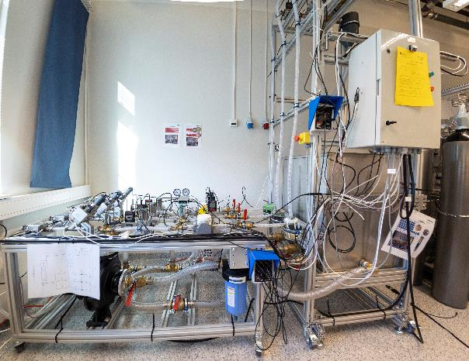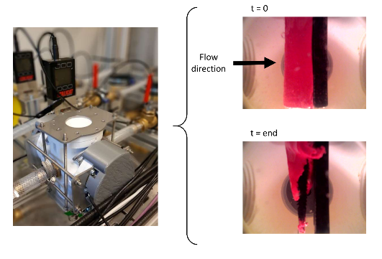

The experimental rig

Intrusive probe is inside

this white “box”

***I like it! What are you looking for in candidates?***

The project is challenging but will give you a chance to learn (in practice) how to model develop and implement a controller. Moreover, it will give you a chance to be creative and come up with technical solutions for a real problem. To successfully complete the project, you should:

* Be interested in modeling and numerical simulation;
* Be familiar with programming;
* Be creative, with a strong ability to work problem oriented.

For more information about the project, contact Associate Professor Johannes Jäschke ([johannes.jaschke@ntnu.no](mailto:johannes.jaschke@ntnu.no)) or Postdoc Jose Otavio Matias ([jose.o.a.matias@ntnu.no](mailto:jose.o.a.matias@ntnu.no))

***Some work that we have been doing***

[1] Verheyleweghen, A.; and Jäschke J.. Oil production optimization of several wells subject to choke degradation. IFAC-PapersOnLine, 51(8):1–6,2018.5

[2] Verheyleweghen, A.; Gjøby, J. M.; and Jäschke J.. Health-aware operation of a subsea compression system subject to degradation. In Computer Aided Chemical Engineering, volume 43, pages1021–1026. Elsevier, 2018.4

[3] Verheyleweghen, A.; and Jäschke J.. Framework for combined diagnostics, prognostics and optimal operation of a subsea gas compression system. IFAC-PapersOnLine, 50(1):15916–15921, 2017.2