## Proposals for specialization projects in Fall 2019

Johannes Jäschke ([jaschke@ntnu.no](mailto:jaschke@ntnu.no))

## Simultaneous production and reliability optimization for complex plants

Production optimization is important to ensure the profitability of chemical plants. Typically, we want to maximize the yield of some desired product, and minimize the consumption of energy. One factor that is commonly overlooked is how operation affects the reliability of the plant. A very energy-efficient, high-yield production strategy is useless if it leads to accelerated degradation and premature failure of the plant. Typically, constraints are imposed on the production in order to avoid this scenario. Unfortunately, this may lead to very conservative and un-economical operation if these constraints are not defined in a systematic manner.

As an alternative, we want to look at how production- and reliability optimization can be integrated into a unified framework. Methods for production optimization are abundant in literature, but little research has been done on how to optimize production and reliability simultaneously. We have previously developed such a framework, and applied it to small case studies successfully. In this project, we want to apply the same framework to a larger and more complex case study.

The tasks of the project are:

* Develop a larger case study. Specifically, this means deriving a mathematical model and implement it in MATLAB or similar software. We have some experience with case studies from oil and gas industry, but the project could also investigate how the framework can be applied to systems from other chemical process industries. Some possible application areas include methanol production with catalyst de-activation or CO2 capture with solvent deterioration.
* Optimization of the developed model using numerical tools in MATLAB or similar software.

We are looking for someone who is interested in modelling and optimization. Some prior exposure to numerical optimization is advantageous, but not required. Since the project will involve a bit of coding, you should also be comfortable with working in MATLAB or similar.

## Hybrid modeling with machine learning and first principles models

Machine learning is becoming a popular tool for various problems from computer vision to chemical process model identification. Despite its many advantages, one of the main drawbacks is that it is often hard to explain the behavior behind the machine learning algorithm. When applied to process systems, these models are often inefficiently used and approximate the input and output variables directly without providing insights about the system behavior.

On another side of the table, we have first principles models which are based on physics behind the phenomena. These models provide a good insight of the system behavior but can be hard to derive and often require empirical calibration to real systems.

In this project, we will explore capabilities of hybrid (“grey box”) modeling by combining first principles physics with machine learning. The focus will be on multiphase flow modeling and estimation in oil and gas production systems. The goal is to create accurate and explainable models using prior knowledge of the process and measurement data. The preliminary tasks are the following:

* Perform a literature review on hybrid modeling in process engineering systems.
* Identify/develop hybrid modelling approaches applicable for multiphase flow estimation.
* Perform simulation case studies using the proposed methods.

The Specialization project’s results can further be used in a Master’s project for modeling and optimization of more complex oil and gas production systems.

The project is challenging but will force you to learn popular and useful approaches which can be used for many applications. If you are not familiar with machine learning, guidance for studying it will be provided. To successfully complete the project, the student should:

* Be interested in modeling, numerical simulation and machine learning
* Be familiar with programming (Python is preferable)
* Have good understanding of process engineering systems and preferably fluid mechanics

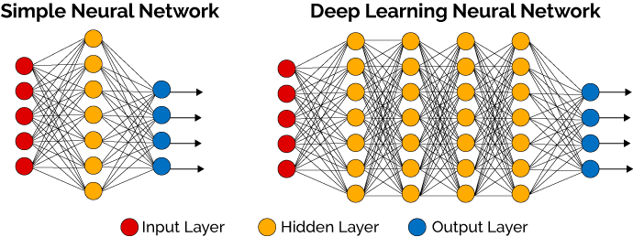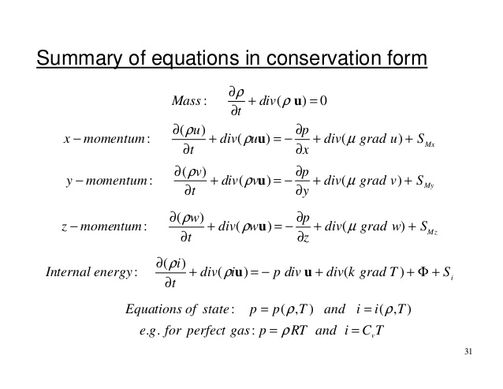

For more information about the project, contact Associate Professor Johannes Jäschke ([johannes.jaschke@ntnu.no](mailto:johannes.jaschke@ntnu.no)) or PhD student Timur Bikmukhametov ([timur.bikmukhametov@ntnu.no](mailto:timur.bikmukhametov@ntnu.no))

## Machine Learning for Uncertainty Modeling of Equipment Degradation

Supervisor: Johannes Jäschke

Co-supervisor: Timur Bikmukhametov

Machine learning has been proved to be a good tool for predictive analytics in various applications. Among many different machine learning algorithms, there are algorithms which are able to predict not only a particular variable value, but also the uncertainty of this prediction. These models are associated with probabilistic modeling of a process using the available data. Examples of such models are Gaussian Processes and Bayesian Neural Networks.

In the oil and gas industry, it is important to monitor degradation of equipment in order to perform planned maintenance and avoid equipment failure. However, there is a lot of uncertainty in this task which has to be taken into account to make an accurate predictions. One potential solution for this problem is to use the probabilistic machine learning algorithms discussed above.

In this project, we will explore capabilities of different methods for uncertainty modeling in equipment monitoring with various machine learning algorithms. One example of such a task can be choke erosion monitoring in an oil well. The preliminary task are the following:

* Develop a machine learning algorithm for uncertainty modeling
* Gather the data for algorithm training (cooperation with NTNU labs is possible)
* Perform simulation case studies using the proposed methods.

The Specialization project’s results can further be used in a Master’s project for modeling and monitoring of more complex oil and gas process equipment.

The project is challenging but will give you an opportunity to use start-of-the-art machine learning methods and program it in Python/Tensorflow/Pytorch/PyMC and so on. If you are not familiar with machine learning, guidance for studying it will be provided. To successfully complete the project, the student should:

* Be interested in machine learning
* Be familiar with programming (Python is preferable)
* Be eager to model complex problems.

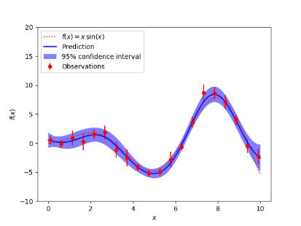

For more information about the project, contact Associate Professor Johannes Jäschke ([johannes.jaschke@ntnu.no](mailto:johannes.jaschke@ntnu.no)) or PhD student Timur Bikmukhametov ([timur.bikmukhametov@ntnu.no](mailto:timur.bikmukhametov@ntnu.no))

## Optimal Design of a Thermal Storage Tank in an Industrial Cluster

Supervisor - Prof. Johannes Jäschke (johannes.jaschke@ntnu.no) Co-supervisor - Mandar Thombre (mandar.thombre@ntnu.no)

Industrial clusters are groups of related companies in a defined geographical area that share common markets, worker skills and technologies. In context of the process industry, this could mean multiple chemical plants sharing energy resources such as steam, cooling water, raw materials, etc. Such a scenario demands flexible operation of the plants, so that surplus energy from one plant is efficiently transferred to another plant in need of it. A thermal energy storage tank that creates a buffer between energy suppliers and consumers is an attractive option to facilitate this transfer. The above figure illustrates

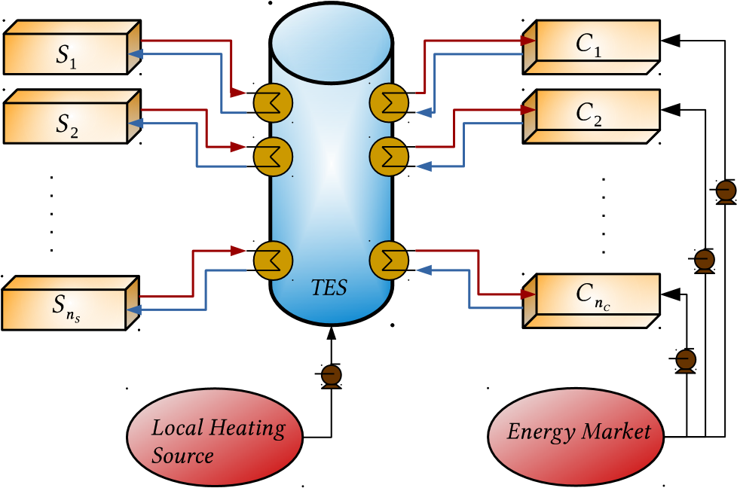

the topology of an industrial cluster with *nS* suppliers (heat sources) and *nC* consumers (heat sinks) of heat, along with one TES tank as buffer. A cheap, but limited, local heating source is available to directly heat up the tank. This local heating source may represent cheaply available flue gases that may be the byproducts of the various chemical processes in the plants. In cases of high volatility with sharp peaks in heat demand on the consumer side, the extra demand can be satisfied by purchasing (expensive) electricity directly from the market to heat up the required process streams. However, this peak-heating market electricity is expensive and significantly increases operational costs in the cluster. The objective, then, is to optimally use the TES tank such that peak-heating is minimized. This can be achieved via a 2-stage approach:

* Optimal Design: Finding the best sizing for the TES tank that can satisfy peak demands over a

long horizon (years).

* Optimal Operation: Using advance control strategies like model predictive control to optimally operate the tank over a short horizon (hours, days).

In this context, tasks in this project would include:

* Modeling: The system topology should be translated into a mathematical model that can be used for dynamic simulation and optimization.
* Problem Formulation: The challenge is to formulate an optimization problem that can simulteneously account for both design and operation.
* Solution Methods: Different optimization methods need to be investigated depending on the complexity of the problem formulation.

The tasks outlined above are for both a specialization project and a further master’s thesis project, and can be divided accordingly. The student interested in this project should:

* Have good understanding of process modeling, process control and optimization theory.
* Be comfortable with programming.

1

## 5 Development of an image measurement software

Supervisor: Johannes Jäschke Cosupervisor: Jose Otavio Matias

**Are you reading through Master project proposals and worried that most of them seem purely theoretical? You might already be thinking of how it would be nice to work in a hands-on project that requires creativity and programming skills. And, that it would also be nice if the Master produces not only a thesis but a nice and useful final product…. What can you do? Give up? Certainly not! This project is perfect for you!**

In this project, we will *develop an online method to determine the erosion rate of components of piping systems* and *model this phenomenon*.

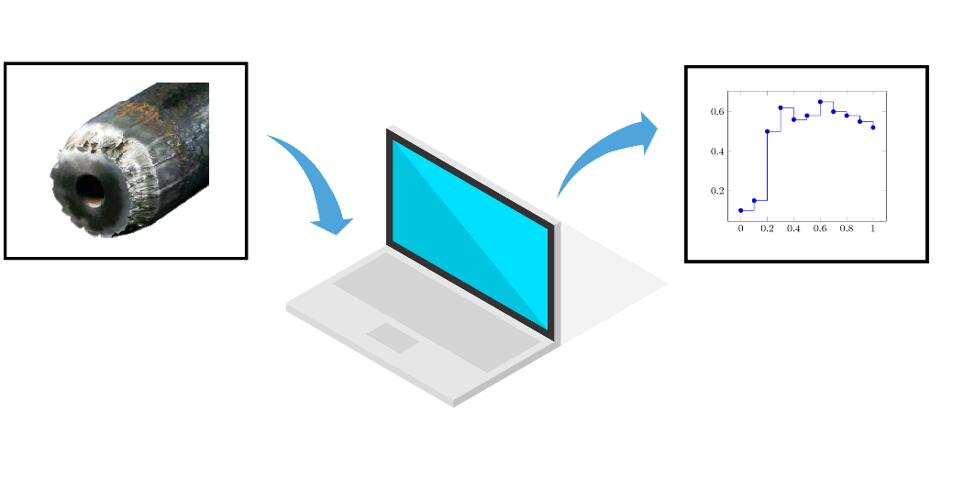

**Ok, cool. But…. Will I sit in front of a computer the whole day? Where is the hands-on?**

No. In parallel with the software development, we will run experiments in the lab. The proposed experimental procedure is based on filming the fluid flow inside an acrylic tube and, by analyzing the images, determine the flow-induced erosion rate in various parts of a piping system. Afterwards, the collected data will be used for modeling/predicting the erosion given the flow pattern, medium and solid content, and so on.

The project will be heavily based on a learning cycle: the theoretical model is developed and the results tested in practice. If the model does not correspond to the reality, or the strategy for measuring the erosion does not work, we go back to the drawing board! This cycle will be important, not only for understanding the theory, but also for learning the process involved with modeling a physical process.

**And how will this software be useful?**

Both the erosion measurement strategy and the erosion models will be used in an ongoing project of [NTNU SUBPRO center](https://www.ntnu.edu/subpro/), a research-based innovation center in partnership with the most important industrial players in the subsea field. This ongoing project aims at designing a lab rig for production optimization and accelerated life testing of critical components. The results of the Master project will be an essential part of it.

**I like it! What are you looking for in candidates?**

The project is challenging but will give you a chance to learn (in practice) how to model a physical process. Moreover, it will give you a chance to be creative and come up with technical solutions for a real problem. To successfully complete the project, you should:

* Be interested in modeling and numerical simulation;
* Be familiar with programming;
* Be creative, with a strong ability to work problem oriented.

For more information about the project, contact Associate Professor Johannes Jäschke ([johannes.jaschke@ntnu.no](mailto:johannes.jaschke@ntnu.no)) or Postdoc Jose Otavio Matias ([jose.o.a.matias@ntnu.no](mailto:jose.o.a.matias@ntnu.no))