# Supervisor Johannes Jäschke

Nonsmooth models for subsea separation systems

**Co-Supervisor: Marlene Louise Lund**

Many processes contain nonsmooth characteristics in the form of non-differentiable “kinks” in the variables as functions of time. In subsea oil and gas production and handling systems, examples of nonsmooth behavior is related to production start-up and shut-down, flow transitions, flow control and thermodynamic phase changes. The traditional way of handling such behavior is using hybrid models, meaning that a set of models for different regimes is developed with discrete transitions between them. However, this strategy leads to models that are challenging both to formulate and solve. New developments within nonsmooth analysis over the past few years facilitates for easy and automatic solving of nonsmooth models using generalized derivatives. The aim of this project is to formulate a nonsmooth model of a three-phase separator that handles continuous transitions between start-up and production. This includes filling the separator as well as transitions between different phase regimes (see [1]).

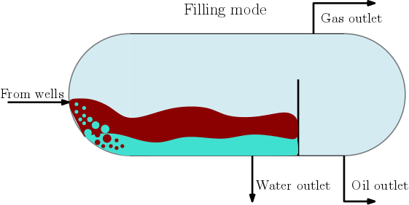 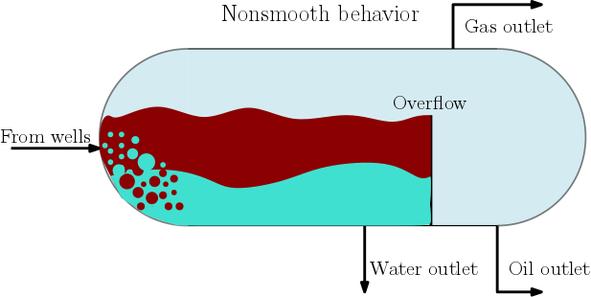

**Tasks:**

* Literature study on nonsmooth analysis
* Study basic separator modeling
* Formulate and implement a separator model using principles form nonsmooth analysis
* Compare with standard modelling methods

Note that this project requires skills within programming (e.g Matlab or another programming language) as well as knowledge about basic mathematics.

[1] Ali M. Sahlodin A., Harry A. J. Watson, and Paul I. Barton, “Nonsmooth model for dynamic simulation of phase changes”, Massachusetts Institute of Technology. Published in *AIChE J*, 62: 3334–3351, 2016.

Python implementation for path-following NLP sensitivity

**Co-Supervisor: Eka Suwartadi**

Optimization based control has shown its ability to handle chemical processes in safe and economic ways. Model predictive control (MPC) has been widely used in process control industry. MPC relies on robust and reliable numerical optimization algorithms. Due to nonlinearity in dynamical systems which modeled the process, nonlinear MPC is employed instead of the linear one. This requires the use of nonlinear programming (NLP) solvers.

For nonlinear systems with fast time constant, a NLP solver may not be able to find optimal solution in the designated allocated time. This can be detrimental for a nonlinear MPC implementation. To mitigate this problem, NLP sensitivity is deployed to speed up the optimization runtime (see [1,2]). The NLP sensitivity is computed by solving a sequence of quadratic programming (QP) solver. Figure below is an illustration of different types of QP problems.

In this project, student will implement path-following NLP sensitivity algorithms particularly the path-following described in [3]. Student will write Python code and test the implementation on several case examples.

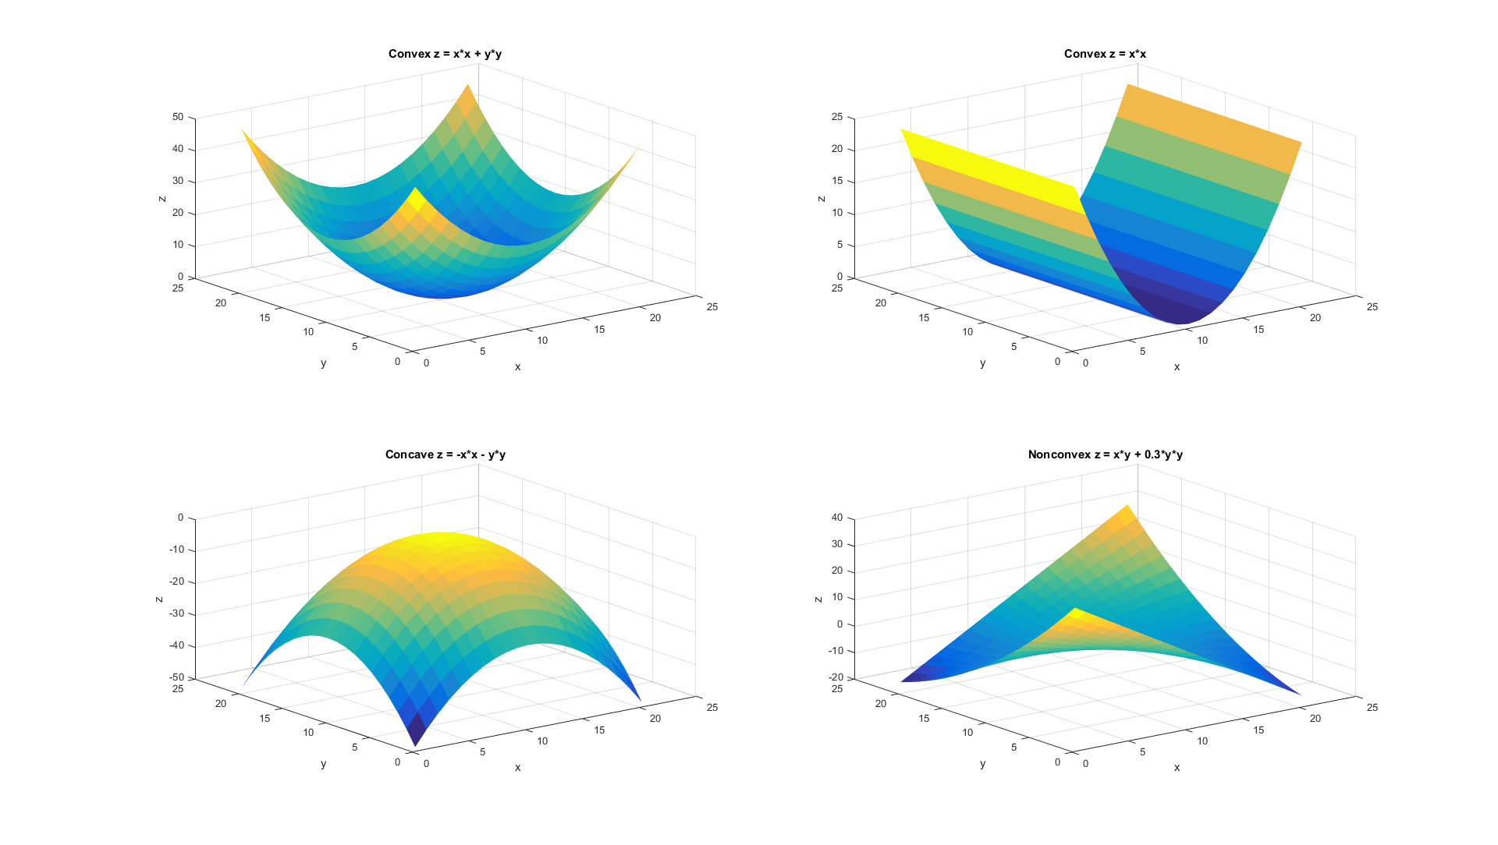

**Tasks**

* Literature study on NLP sensitivity
* Study numerical optimization algorithms for NLP sensitivity
* Assess efficient quadratic programming (QP) solvers for computing NLP sensitivity
* Write Python code for NLP sensitivity which may include interfaces for existing QP solvers
* Perform testing for the Python implementation for several case examples
* Analyse and foresee the application of NLP sensitivity for nonlinear MPC implementation

Student involved in this work will learn efficient numerical optimization algorithms and get hands-on experience in developing numerical software algorithm. It will be great if the student can contribute to open source numerical optimal control software package such as CasADi.

[1] Diehl, M., Bock, G.H., Schlöder, J.P., Findeisen, R., Nagy, Z., and Allgöwer, F., Real-time optimization and nonlinear model predictive control of process governed by differential-algebraic equations. Journal of Process Control, Volume 12, pp. 577-585, 2002.

[2] Zavala, V.M., and Biegler, L.T., The advanced-step nmpc controller: optimality, stability, and robustness. Automatica, Volume 45, pp. 80-93, 2009.

[3] Suwartadi, E., Kungurtsev, V., and Jäschke, J., Sensitivity-based economic nmpc with a path-following approach. Processes, 5:1, 2017.

Economic model predictive control of oil gathering network

**Co-Supervisor: Eka Suwartadi**

This project may be done for a group of students since the implementation is not straightforward and requires a good understanding of Kalman Filter and nonlinear model predictive control (NMPC). Idea for this project is from the paper of Codas et. al [1]. Process described in the paper includes a network of two gas-lift oil wells, a common pipeline-riser system and a separator (see figure below). The modeling part is done by using dynamics simulation tool Modelica and real plant model is simulated by using OLGA (multiphase flow simulator). The NMPC implementation is facilitated by CasADi with OpenOPC data communication to OLGA. The whole system implementation is in Python programming language.

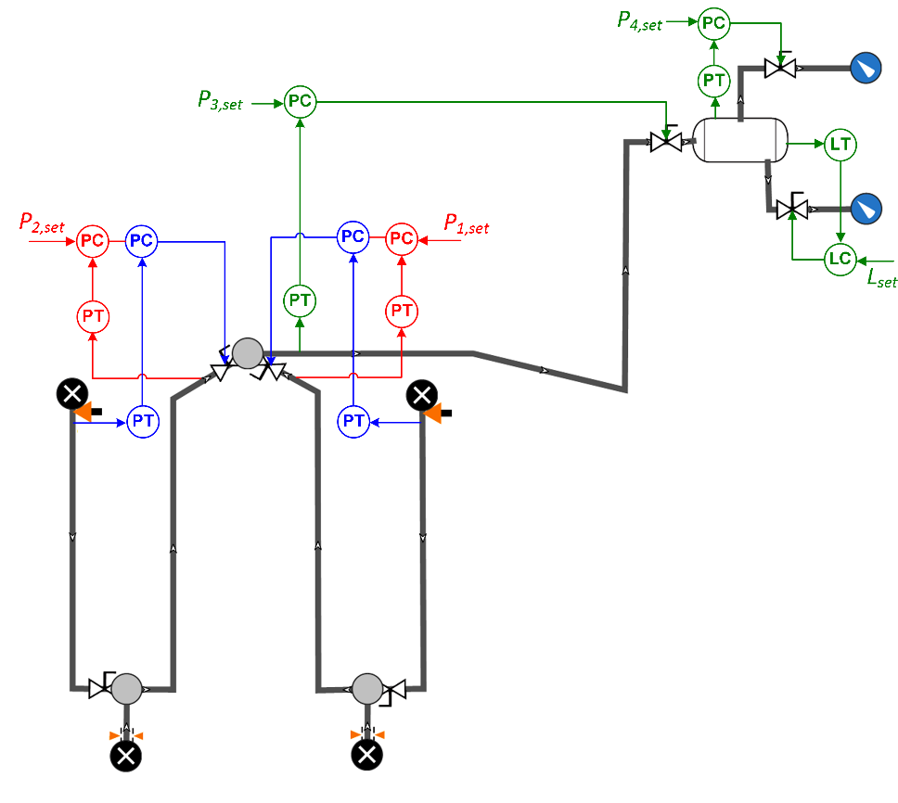

**Tasks**

* First task is to understand the system dynamics. Students will run the existing model and get to know the simulation tools (Modelica, CasADi, and OLGA).
* Literature study on numerical optimization control implementation especially the integration schemes such as single shooting, multiple shooting, and collocation methods.
* Develop economic MPC controller using collocation method instead of multiple shooting which has been implemented in the paper.
* Assess the possibility to speed up the simulation for example using distributed computing platform (multicore CPUs).

[1] Codas, A., Jahanshahi, E., and Foss, B., A two-layer structure for stabilization and optimization of an oil gathering network. In the proceeding of 11th IFAC symposium on dynamics and control of process systems including Biosystems, June 6-8, 2016. NTNU, Trondheim, Norway.

# Modelling of Åsgard subsea gas compression station for condition monitoring purposes

**Co-supervisors: Adriaen Verheyleweghen and Tamal Das**

Subsea production and processing of oil and gas can potentially help solve many of the problems associated with platform-based production. By putting the processing equipment on the seabed, we can operate in harsh conditions, far away from the shore, and without need for manned platforms. However, to avoid costly breakdowns that require intervention, it is necessary to have good condition-based maintenance routines. Since we are usually not able to measure the condition of the system directly, we need to estimate it from other plant measurements.

The purpose of this project is to model the Åsgard subsea gas compression station, with the specific goal to use the model for condition monitoring purposes. The student will develop models for estimating the health state of the systems (system diagnostics), but also models which predict the future health degradation of the system if possible (system prognostics). It is advantageous if the student is comfortable with programming in MATLAB and has knowledge of basic optimization.

Expected tasks and learning outcomes:

* Literature study of subsea process systems and condition monitoring
* Modelling of the Åsgard compression station
* Condition monitoring using Kalman filters / moving horizon estimation

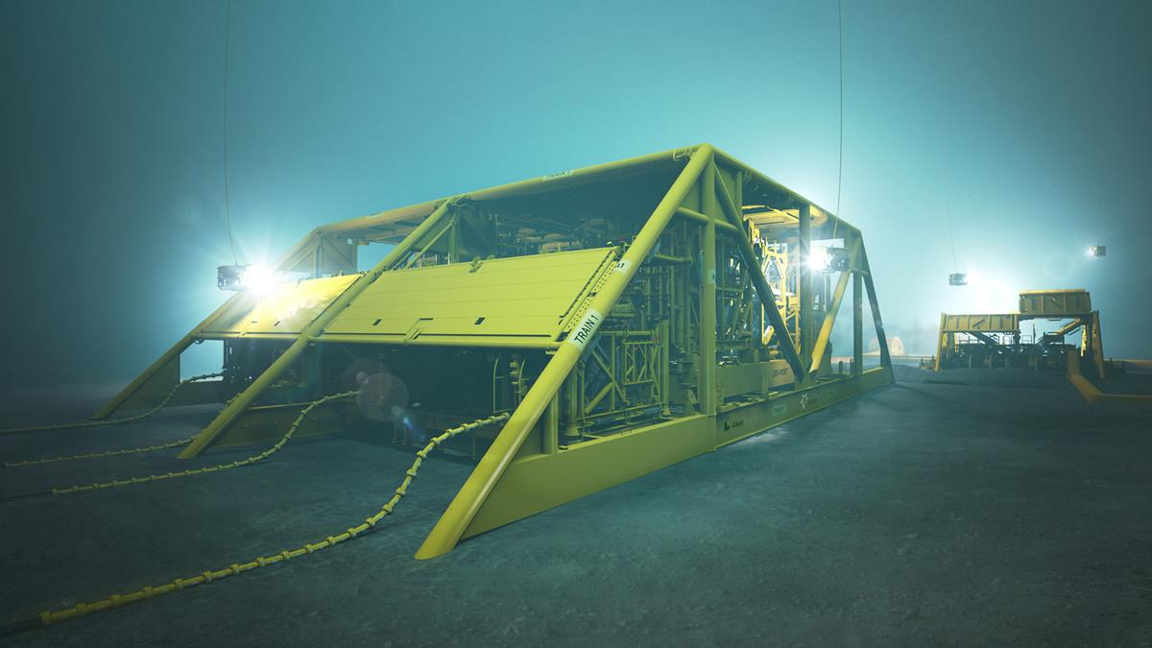

Figure 1: Artist rendition of the Åsgard gas compression station. Copyright: Aker Solutions

# Optimal control of a LNG plant

**Co-supervisor: Adriaen Verheyleweghen**

Efficient energy use is a growing industrial challenge in today’s competitive market. This is especially true in large, energy-demanding processes such as refrigeration cycles in the petrochemical industry. Due to the significant power consumption, optimizing the operation of such processes is key. Because many degrees of freedom are available for control, finding the optimal strategy may be non-trivial.

The purpose of this project is to improve an existing model of a LNG liquefaction plant and compare different control strategies, such as self-optimizing control and model predictive control. It is advantageous if the student is comfortable with programming in MATLAB and has knowledge of basic optimization.

Expected tasks and learning outcomes:

* Literature study of refrigeration plants and optimal control strategies
* Modelling of a LNG plant
* Comparison of several control strategies



Figure 2: Cascade refrigeration system for natural gas liquefaction

# Anti-slug Lab

**Co-supervisor: Tamal Das and Sigurd Skogestad**

In multiphase flows, gas and liquid phases coexist to form several diﬀerent flow regimes. Commonly known flow regimes include stratified flow, bubbly flow etc. The flow regimes adopted by fluids in a pipe are largely dependent on the gas flow rate, the liquid flow rate and the orientation of the pipe. In the vertical orientation of the pipe with the fluids flowing upwards, it is sometimes challenging to ensure a uniform flow, especially in a flow regime called slug flow. In slug flow, there is a pressure built up at the bottom of the vertical pipe near the inlet because the vertical pipe is fully filled with a liquid column. Eventually, the gas pressure rises higher than the hydrostatic pressure in the column causing a blowout of the liquid column. This causes alternating periods of no flow and blow outs. Hence, from a process engineering perspective slug flow is undesirable. A common approach to avoid slugging is to decrease the inlet flow by choking down the inlet valve. However, this approach leads to reduced throughput. Automatic control of the bottom pressure (or similar approaches) in order to avoid slugging is known as anti-slug control. In this project, the student will have access to the anti-slug lab (with a computer running LABVIEW with manual/automatic control, where the whole process can be visualized), where the student will get familiarized to the phenomenon of slugging and how to control it using the available choke valves in order to ensure uniform flow.

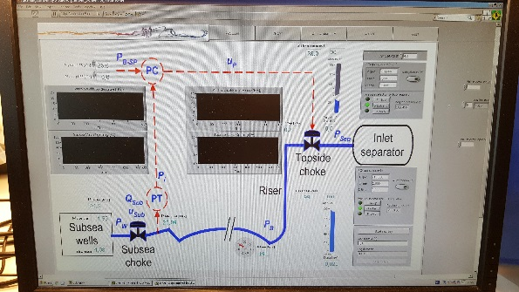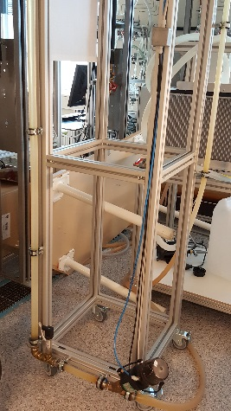

To systematically design an anti-slug controller, one needs a model, which has already been developed in the group [1]. This model will be the basis for some analysis. Once the basic understanding of the model based controller design is in place, the student will develop under-standing of state estimation to estimate the unmeasured variables in the model presented in [1] using the available measurements, such as pressures. Further, state estimation principles can be used for flow estimation and slug detection, which can be verified against the data from LABVIEW. The estimated variables could be used in the control design.

State estimation is usually dependent on the measurements. What if the measurements are slightly wrong because the sensor is malfunctioning, i.e. the pressures measured have a bias. Accurate information of the unmeasured variables can still be retrieved using gross error detection [2].

Finally, all state estimation methods rely on tuning of the estimators (such as Kalman filters). The tuning usually refers to determining process noise covariance matrix and the measurement noise covariance matrix. These matrices are hard to get in real applications. Hence, a method called auto-covariance least squares [3] will be used to see how much it impacts the estimation performance. The student can direct the project to his/her liking.

References

1. E. Jahanshahi, “Control solutions for multiphase flow: Linear and nonlinear approaches to anti-slug control,” 2013.
2. B. Nicholson, R. L´opez-Negrete, and L. T. Biegler, “On-line state estimation of nonlinear dynamic systems with gross errors,” Computers & Chemical Engineering, vol. 70, pp. 149–159, 2014.
3. B. J. Odelson, A. Lutz, and J. B. Rawlings, “The autocovariance least-squares method for estimating covariances: application to model-based control of chemical reactors,” IEEE transactions on control systems technology, vol. 14, no. 3, pp. 532–540, 2006.

# Temperature and light intensity control

**Co-supervisor: Tamal Das**

Learning process control on real applications is exciting. Hence, we oﬀer a project to learn from experimenting with process control strategies on a small equipment known as PSE-5. The underlying process is a MIMO system (Multiple input multiple output), with three inputs and two outputs. The inputs are LED (L), BULB (B) and FAN (F) and the outputs are LIGHT-INTENSITY (LI) and TEMPERATURE (T). L and B aﬀect the LI with a zero order dynamics, whereas B and F aﬀect the T with a first order dynamics.

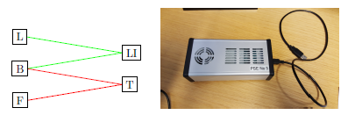

The system can be easily plugged into a computer and visualized in SIMULINK, from where one could easily do manual or automatic control. The project will start with system identification using MATLAB system identification toolbox. Using the identified model, the control will be designed. Ideally speaking, T control using PID is very easy if using only B. However, a faster control can be achieved with using both B and F (MIMO control). On the other hand F could be used as a disturbance. Similarly, for the LI control, both B and L can be used. If one wants to control the LI without impacting the T, L is the best choice as the manipulated variable. But, L has a limit to which it can aﬀect the LI. For higher LI, one needs to use B, but B aﬀects the T. Hence, to do a combined control of T and LI, one needs to use all the inputs in an optimal way, which could lead to some optimal control strategies, such as, but not limited to, linear quadratic regulator.

Next, some state estimation principles will be used to estimate some variables considered un-measured (even though they are measured), such as bulb power or fan speed. This will be done to verify how accurate the estimation works against the measured values for the same variables. State estimation is usually dependent on the measurements. What if the measurements are slightly wrong because the sensor is malfunctioning, i.e. the temperature measured has a bias. Accurate information of the unmeasured variables can still be retrieved using gross error detection [1].

Finally, all state estimation methods rely on tuning of the estimators (such as Kalman filters). The tuning usually refers to determining process noise covariance matrix and the measurement noise covariance matrix. These matrices are hard to get in real applications. Hence, a method called auto-covariance least squares [2] will be used to see how much it impacts the estimation performance.

The student can direct the project to his/her liking.

References

1. B. Nicholson, R. L´opez-Negrete, and L. T. Biegler, “On-line state estimation of nonlinear dynamic systems with gross errors,” Computers & Chemical Engineering, vol. 70, pp. 149–159, 2014.
2. B. J. Odelson, A. Lutz, and J. B. Rawlings, “The autocovariance least-squares method for estimating covariances: application to model-based control of chemical reactors,” IEEE transactions on control systems technology, vol. 14, no. 3, pp. 532–540, 2006.

# Flow estimation

**Co-supervisor: Tamal Das**

Virtual flow metering is estimation of flow using easily available measurements, such as pressure and temperature. This field of research is very sought after because physical flow meters, especially for multiphase flows, are very expensive and tend to be inaccurate. In subsea oil and gas industry, accurate measurement/estimation of phase flows are important because the revenues for the companies sharing the same production infrastructure rely on it. This project will rely on state estimation techniques, such as Kalman filtering, Extended Kalman filtering, Moving horizon estimation to name a few. Based on which techniques are used, the student can have exposure to Kalman based filtering methods or optimization based moving horizon estimation. Moving horizon estimation will involve dynamic optimization using CasADi, an algorithmic diﬀerentiation tool. For state or parameter estimation, one needs a model. In the literature, there exist several models. These models fit into diﬀerent classes of flow estimation: static or dynamic estimation, two phase model or three phase model, no slip between gas-liquid or slip between gas-liquid (Drift flux model), unilateral wells (without tie-ins) or multilateral wells (with tie-ins), flow regime dependent models or flow regime independent models.

The project will commence with a quick literature survey on flow estimation oriented mod-els. Simultaneously, the student will deepen understanding in state estimation techniques and casADi (if dynamic optimization based estimators are chosen). Based on this, flow estimation will be tested in MATLAB/Modelica (Dymola/OpenModelica) using relevant models found in the literature. These models will be the basis for some further analysis. The next step would be to test the flow estimation methods against the industry approved dynamic multiphase flow simulator OLGA. It is possible to connect OLGA to MATLAB/Modelica using an OPC server such as Matrikon.

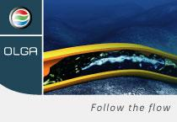State estimation is usually dependent on the measurements. What if the measurements are slightly wrong be-cause the sensor is malfunctioning, i.e. the pressures measured have a bias. Accurate information of the unmeasured variables can still be retrieved using gross error detection [1]. This could be a potential direction for developing an estimator robust to gross error.

Finally, all state estimation methods rely on tuning of the estimators (such as Kalman filters). The tuning usually refers to determining process noise covariance matrix and the measurement noise covariance matrix. These matrices are hard to get in real applications. Hence, a method called auto-covariance least squares [2] will be used to see how much it impacts the estimation performance.

The student will have the flexibility to direct the project to his/her own liking.

References

1. B. Nicholson, R. L´opez-Negrete, and L. T. Biegler, “On-line state estimation of nonlinear dynamic systems with gross errors,” Computers & Chemical Engineering, vol. 70, pp. 149–159, 2014.
2. B. J. Odelson, A. Lutz, and J. B. Rawlings, “The autocovariance least-squares method for estimating covariances: application to model-based control of chemical reactors,” IEEE transactions on control systems technology, vol. 14, no. 3, pp. 532–540, 2006.

# Condition monitoring of choke valves

**Co-supervisor: Adriaen Verheylewegen and Tamal Das**

In subsea processing of oil and gas, equipment redundancy is crucial to ensure no loss in production. One of the drawbacks of having equipment on the seabed is that they can not be maintained all the time. Any major or minor changes to the equipment or retrieval for maintenance needs to be planned much in advance. Hence, it is important to monitor the condition of the critical equipments that tend to breakdown frequently. For a quick overview on the subsea condition monitoring systems, refer [1].

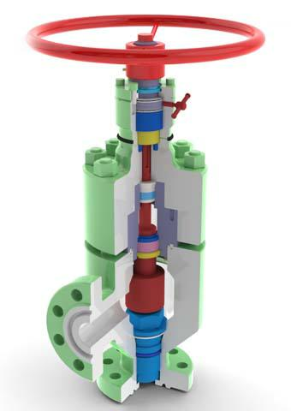Choke valves can break down due to many failure mechanisms. Sand erosion and corrosion are a few of those. In this project, we will focus on determining the condition of choke valves using commonly available measurements around the choke valves, such as diﬀerential pressure between inlet and outlet. The condition can be estimated using a mathematical model, some measurements and state/parameter estimation techniques. For example, the pressure, temperature and flow rate measurements can be used to estimate the current flow coeﬃcient (Cv) of a choke valve. This Cv can be compared to the reference Cv (from vendors); if it is higher than the reference, it is likely that the choke valve has a damage. If there are major changes in current Cv, it indicates accelerated damage [2]. Choke flow models can be found in [3] and erosion models can be found in [4].

The project will commence with a quick literature survey to identify the relevant models. Then, the models will be used to predict the condition of the choke valves. The overall choke valve behavior is a gross indicator of worsening condition, which could be aﬀected due to several failure mechanisms. We intend to focus on erosion and corrosion. The result of this project will be a system that can take the necessary measurements and provide some variables that are key indicators of health of choke valves, such as Cv (diagnostic) and how these variables will develop in future (prognostic).

State estimation methods such as Kalman filters will be used to fuse the information from the models and the measurements to estimate the condition of the choke valve. The tuning of filters are hard in real applications, which usually means determining process noise covariance matrix and the measurement noise covariance matrix. Hence, a method called auto-covariance least squares [5] will be explored.

The student can direct the project to his/her liking.

References

1. L. P. Chze, C. W. Liam et al., “Optimising data processing for subsea system surveillance through subsea condition monitoring,” in Oﬀshore Technology Conference Asia. Oﬀshore Technology Con-ference, 2016.
2. C. Soosaipillai, P. K. Roald, D. Alfstad, T. Aas, G. Smith, J.-Y. Bressand et al., “Condition perfor-mance monitoring for subsea: Experience and value documentation from the gjoa field,” in Oﬀshore Technology Conference. Oﬀshore Technology Conference, 2013.
3. R. Sch¨uller, T. Solbakken, S. Selmer-Olsen et al., “Evaluation of multiphase flow rate models for chokes under subcritical oil/gas/water flow conditions,” SPE production & facilities, vol. 18, no. 03, pp. 170–181, 2003.
4. R. Paggiaro, J. D. Friedemann, E. Gharaibah, Y. Zhang et al., “Prediction of sand erosion in choke valves-cfd model development and validation against experiment,” in OTC Brasil. Oﬀshore Tech-nology Conference, 2013.
5. B. J. Odelson, A. Lutz, and J. B. Rawlings, “The autocovariance least-squares method for estimating covariances: application to model-based control of chemical reactors,” IEEE transactions on control systems technology, vol. 14, no. 3, pp. 532–540, 2006.

# Compact flotation unit model

**Co-supervisor: Tamal Das**

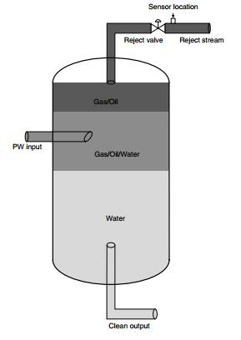In subsea oil and gas industry, produced water treatment is a significant chal-lenge. Produced water (PW) is the water produced along with oil from the reservoir. After the bulk separation of oil and water, the separated water still con-tains amount of oil that is neither suitable for reinjection into the reservoir nor for rejection into sea. Commonly used equipment in the industry to reduce the oil-in-water content in produced water to ppm levels are hydrocyclones (HC) and Compact flotation units (CFU) [Figure 1]. Recent advances in CFUs for produced water treatment and their functional description can be found in [2]. In this project, we want to develop a steady state model of a CFU in order to calculate the separation eﬃciency under given PW flow rate and gas flow rate. Some mechanisms for CFU modeling can be found in [3]. Additional information about operation and optimization of PW in CFU can be found in [4].

The next step would be to develop a dynamic model that can provide the purity of the outgoing streams based on the inlet and operating conditions. This model will be used for controlling the process or estimating key variables of interest using available measurements. The student will, therefore, deepen understanding of state and parameter estimation techniques, such as Kalman Filters.

Key inspiration for the modeling work can be found in two chapters, namely Equipment for Gas-Liquid Operations (Chapter 6) and Gas Absorption (Chapter 8) in [5] and example 18.4-1 in [6]. Further, gas flotation theory will be explored to develop the model.

The student can direct the project to his/her liking.

References

1. B. K. Arvoh, S. Asdahl, K. Rabe, R. Ergon, and M. Halstensen, “Online estimation of reject gas and liquid flow rates in compact flotation units for produced water treatment,” Flow Measurement and Instrumentation, vol. 24, pp. 63–70, 2012.
2. M. Bhatnagar, C. J. Sverdrup et al., “Advances in compact flotation units (cfus) for produced water treatment.” in Oﬀshore Technology Conference-Asia. Oﬀshore Technology Conference, 2014.
3. M. Maelum, K. Rabe et al., “Improving oil separation from produced water using new compact flota-tion unit design,” in SPE Production and Operations Symposium. Society of Petroleum Engineers, 2015.
4. S. Asdahl, K. Rabe et al., “Real-time automatic operation and optimization of produced-water treat-ment,” in SPE Middle East Intelligent Energy Conference and Exhibition. Society of Petroleum Engineers, 2013.
5. R. E. Treybal, “Mass transfer operations,” New York, 1980.
6. R. B. Bird, W. E. Stewart, and E. N. Lightfoot, Transport phenomena. John Wiley & Sons, 2007.